**Getting to know you at home**

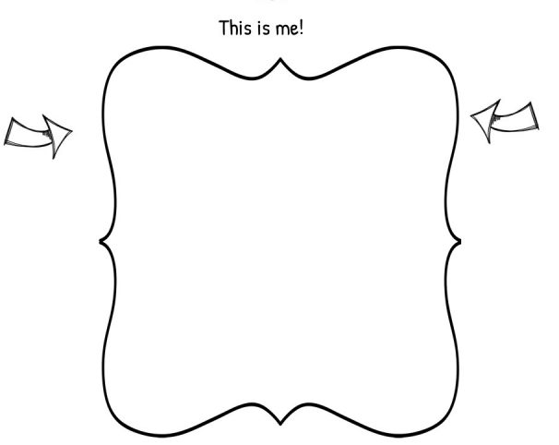

**Name___________________________________**

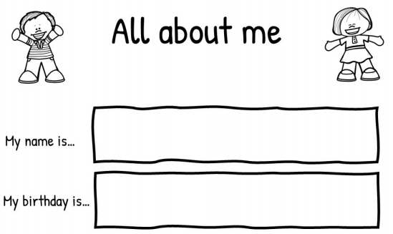

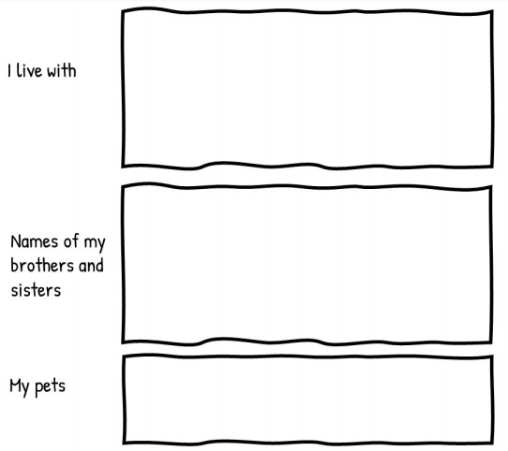

Feelings

This is how I feel about starting school

This is my face

**Parent Comments…**

**My favourite colour is…**

**My favourite toys…**

**3 words to describe me…**

**My favourite food and drink…**



**My favourite stories…**



**My favourite film/TV show…**



**Some things that make me happy…**



**These things relax and soothe me…**



**My interests…**



**My favourite song/rhyme…**



**These are all the things I’m good at!!**

**Now I am getting big I can…**



I can put on my coat: yes nearly no

I can dress myself: yes nearly no

I can put on my shoes: yes nearly no

I can use the toilet myself: yes nearly no

I can recognise my name: yes nearly no

**My Friend**

Their name is…



**This is a picture of them**



**I like them because…**



**Things I am looking forward to at school**

**My worries about school**

**Something I have done over the summer**

**Parent concerns or questions**



Thank you for taking the time to fill this in – it will be so useful in getting to know your child and help them to settle in at Ashbury Primary School. We can’t wait to welcome you to Berrycroft in September!!